IT Project Guidance

Delivery Support Systems to Consider

## Description

This document describes delivery systems to consider when planning, procuring, configuring, provisioning, and integrating, to in turn facilitate the lifelong maintenance of an IT system used by service consumers.

## Synopsis

The delivery of an information service to meet service consumers expectations over a service lifespan requires the identifying, planning, delivering, provisioning, and integrating, and coordinating of services to assist with the collection of issues and desires, their development into requirements that in turn are the basis of prioritised work items, which in turn incrementally improve the system itself, and it s underlying automated delivery system that delivers it in an idempotent and secure manner.

## Contents

Description 1

Synopsis 1

Contents 2

Introduction 3

Background 3

Issue 3

Resolution 3

Systems 4

Project Delivery Services 5

Communication and Virtual Meeting Service 5

Work Management Service 5

Wiki Service 5

Documentation Management Service 6

Technical Delivery Services 6

Versions Control Code Management Service 6

Compilation, Packaging and Deployment Pipeline Service 7

Appendices 8

Appendix A - Document Information 8

Images 8

Tables 8

References 8

Review Distribution 8

Audience 8

Structure 8

Diagrams 8

Terms 9

# Introduction

## Background

The terminology used when discussing delivering systems leads to stakeholders concentrating on delivering the system that end users will be using.

## Issue

While delivering an automated system for users to use is evidently an important project outcome. But deliveries that are omit the delivery of a means to provide regular maintenance of the information within the system and the system itself soon change from being assets to liabilities.

Automation should be used to automate its assurance and deployment of both the above systems so that once ongoing deployments are rapid and do not introduce unnecessary risk.

## Resolution

Identifying, planning, procuring, deploying, configuring, and identifying the services needed to deploy a business service in a repeatable automated manner reduces project risk.

# Systems

While it may seem obvious that systems are just the automation of repeatable human processes, it is common for ICT projects to miss the obviousness that project delivery processes can be automated as well.

Support Services can be broadly categorised into three groups as follows:

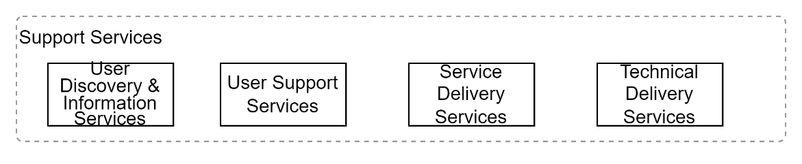

Figure 1: Support System Categories

* **User Discovery Services:** the services that end users can access to discover and inform themselves as to the service, it’s purpose, its value, and support options.
* **User Support Services:** the services that end users can access to discover, inform themselves, get support, and potentially raise an issue for delivery stakeholders to consider how to prioritise.
* **Service Delivery Services**: the services that service delivery stakeholders use to collate their desires, convert them to analysed and contractually acceptable definitions, for prioritisation as to when to hand them over for technical development, delivery, operations, and maintenance.
* **Technical Delivery Services**: the services that technical delivery stakeholders use to develop new systems, their packaging, deployment, configuration, provisioning with information and monitoring.

## Project Delivery Services

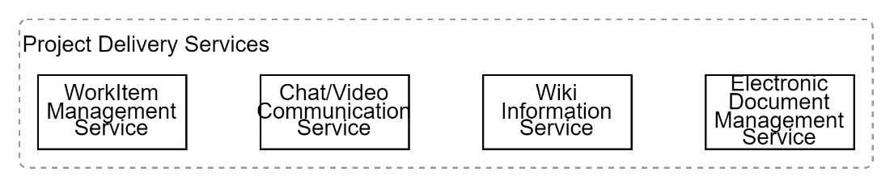

Figure 8: Project Delivery Services\

Project delivery services manage people, communications, decisions, and work items of user and business stakeholders.

### Work Item Management Service

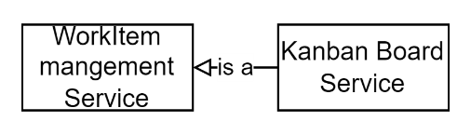

Figure 9: Work Management Service

Delivery team members manage business service development tasks, their prioritisation, and assignment, using a Work Item Management Service.

Before such services can be used, they require configuration to create a project specific workspace, kanban board, filters, and reports.

A Backlog is required to manage work items that are either incomplete in definition, or not yet certain to be developed.

The service is required to be accessible by invited shareholders that are either internal to the organisation and external (consultants, vendors).

Note:  
well-known examples might include JIRA, GitLab, GitHub Boards.

Important:  
Requirements are contractual statements, whereas Agile work items are task statements to meet them. They must not be confused.

### Communication and Virtual Meeting Service

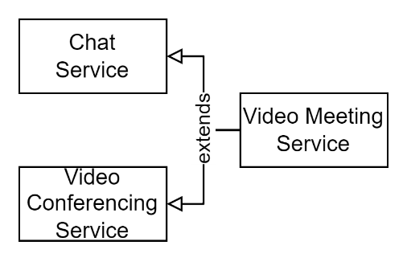

Figure 10: Team Communication Services

Delivery teams use text and visual communications services to permit collaborating asynchronously on developing and progressing work items on the kanban.

Note:  
well known examples include Microsoft Teams, Slack, etc.

### Wiki Documentation Service

Project members require a service to develop project management artefacts that are not deliverables.

Common information that is recorded in a project wiki include: An executive summary, Onboarding, guidelines, constraints, processes, registries (stakeholders, constraints (milestones, regulations, policies, agreements, principles), decisions, risks, issues, engagements, communications, etc.).

Note:  
well known examples include Confluence.

### Electronic Documentation Management Service

While a wiki can be used to develop and collate information, and a competent wiki can host documents, and to some extent manage workflows, a wiki isn’t an appropriate tool to develop or manage electronic document deliverables in an auditable, versioned manner.

A digital documentation management system (EDMS) is a more appropriate place to store documents, with necessary access controls to limit access to project members, auditing their collaboration and access.

For collaboration reasons, the service should permit the invitation of different users to collaborate on documents.

For information quality reasons, the service should permit commenting by resources invited to comment and/or modify the document.

For traceability and accountability reasons, the service should manage versioning of documents.

For availability by external partners, vendors, and RFx respondents, the service should be web based, permitting the creation of unique links to share the resource without giving access to other resources in the EDS.

Note:  
well known examples include SharePoint backing O365’s Teams project files.

## Technical Delivery Services

Appendix A - Document Information

Author & Contributors

Sky Sigal, Solution Architect

### Images

Figure 1: System Categories 4

Figure 2: Delivery Services 5

Figure 3: Code Types 7

### Tables

**No table of figures entries found.**

### References

**There are no sources in the current document.**

### Review Distribution

The document was distributed for review as below:

|  |  |
| --- | --- |
| Identity | Notes |
|  |  |
|  |  |
|  |  |

### Audience

The document is technical in nature, but parts are expected to be read and/or validated by a non-technical audience.

### Structure

Where possible, the document structure is guided by either ISO-* standards or best practice.

### Diagrams

Diagrams are developed for a wide audience. Unless specifically for a technical audience, where the use of industry standard diagram types (Archimate, UML, C4), is appropriate, diagrams are developed as simple “box & line” monochrome diagrams.

### Terms

Refer to the project’s Glossary.

##### ISO-25012

: the internationally defined list of expected *Data* Qualities. The qualities are: *Accuracy, Completeness, Consistency, Credibility, Currentness*, dependent on the information’s *Accessibility, Compliance, Confidentiality, Efficiency, Precision, Traceability*, and *Understandability*, which in turn are dependent on the information’s *Availability, Portability, and Recoverability* qualities.

##### ISO-25010

: the internationally defined list of expected Qualities of a *System*. These qualities are expected of systems, within which data is managed. The full list of desirable system qualities are organised into the following category: *Functional Suitability, Performance Efficiency, Compatibility, Usability, Reliability, Security, Maintainability and Portability*.